Hadoop practice code
DAY 1
- Create /tmp/<yourname> in HDFS
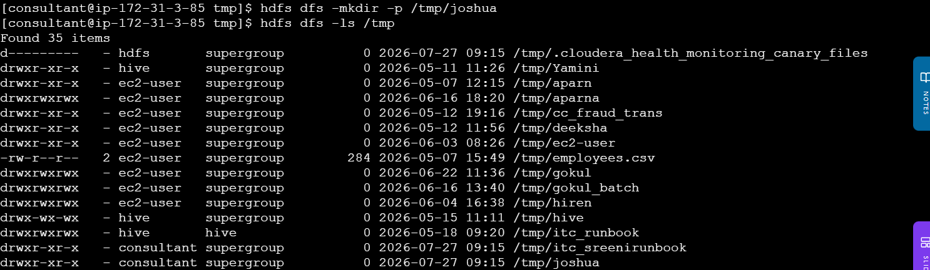
Upload employees.csv to it
Print it with -cat — verify all 10 rows
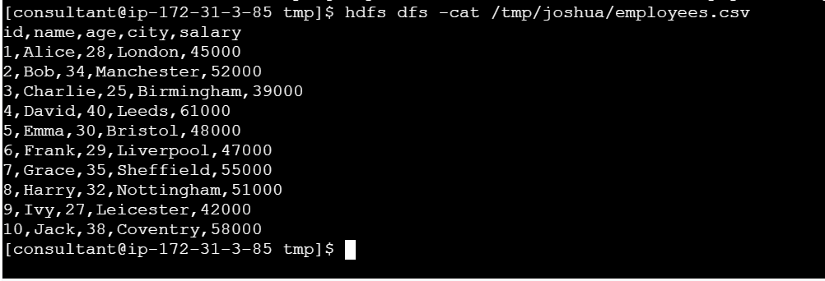
Confirm replication = 3 in the -ls output
Check size with -du -s -h
- Change replication to 2 with -setrep and verify
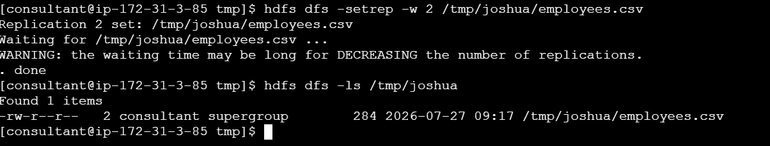
Day 2
Write a city counter MapReduce job using Python streaming

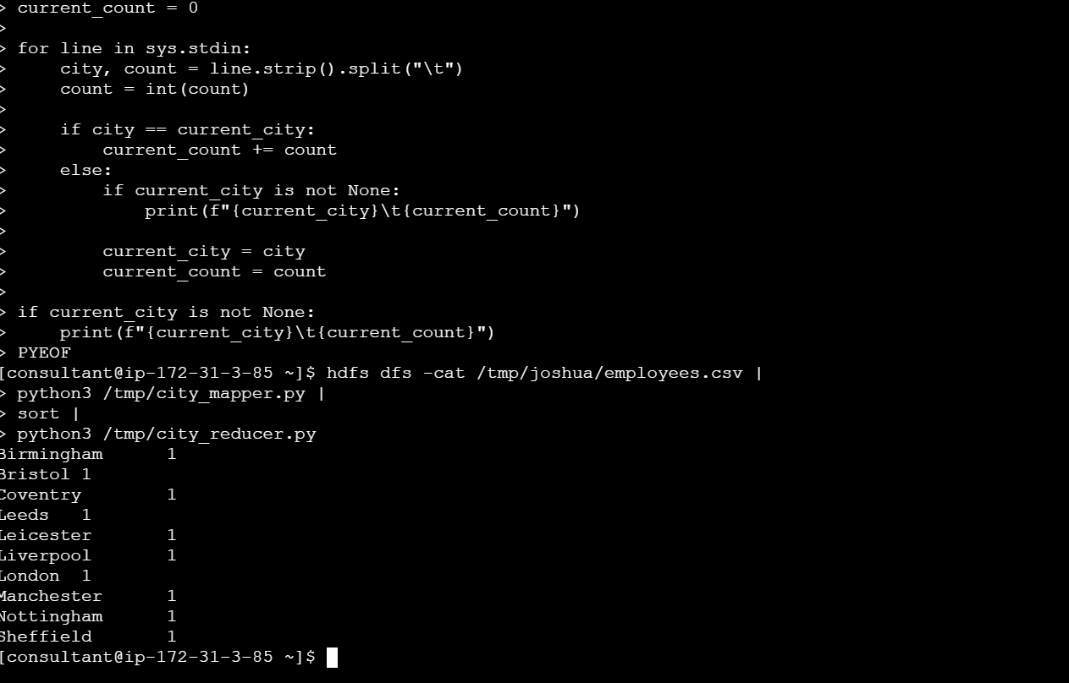
Mapper: skip the header, emit city\t1 for each row
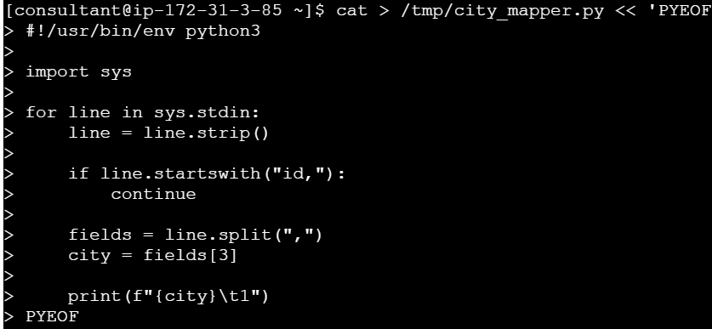
Reducer: count employees per city
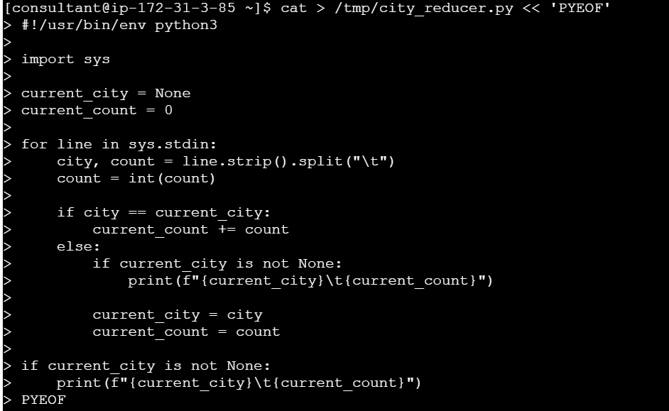
Expected output: London\t1, Leeds\t1, Manchester\t1, etc
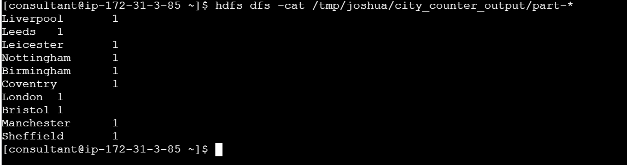
DAY 3
- Run hdfs dfsadmin -report — note which DataNode has the most space used
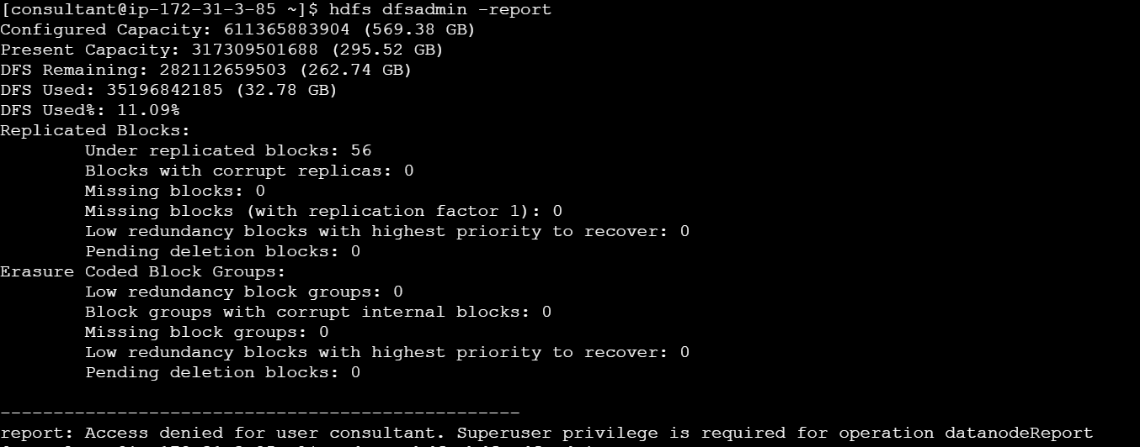
- Run hdfs fsck /tmp/itc_runbook -files -blocks — confirm all blocks are HEALTHY
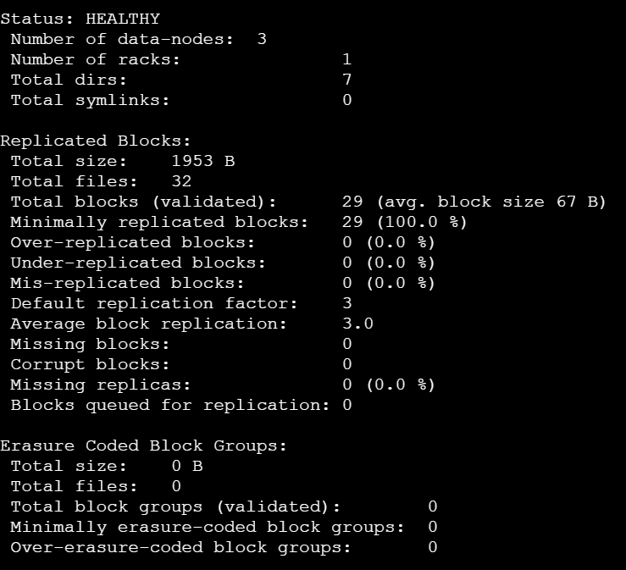
- Enable snapshots on /tmp/<yourname>, create a snapshot called day3_checkpoint
Didn’t have permissions to create snapshot so

- Delete employees.csv from your directory, then restore it from the snapshot
- Use distcp to copy /tmp/<yourname> to /tmp/<yourname>_backup
- Confirm the copy: hdfs dfs -du -h /tmp/<yourname>_backup
- Delete the snapshot and backup when done

DAY 4
- Run yarn node -list — note which node has the most containers
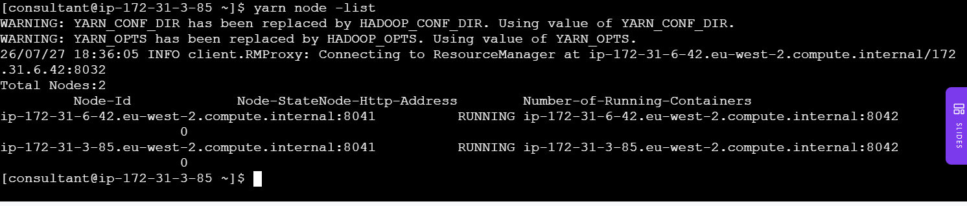
- Submit the MapReduce WordCount again
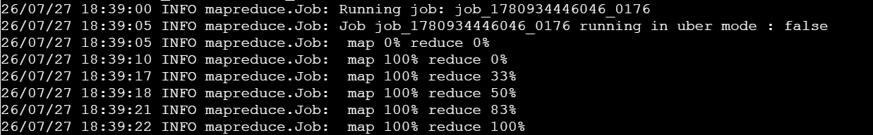
- While it runs, open http://13.41.167.97:8088 and watch it in the YARN UI
Doesn’t open to a page for me
- After it finishes, use yarn logs -applicationId <id> to see the output
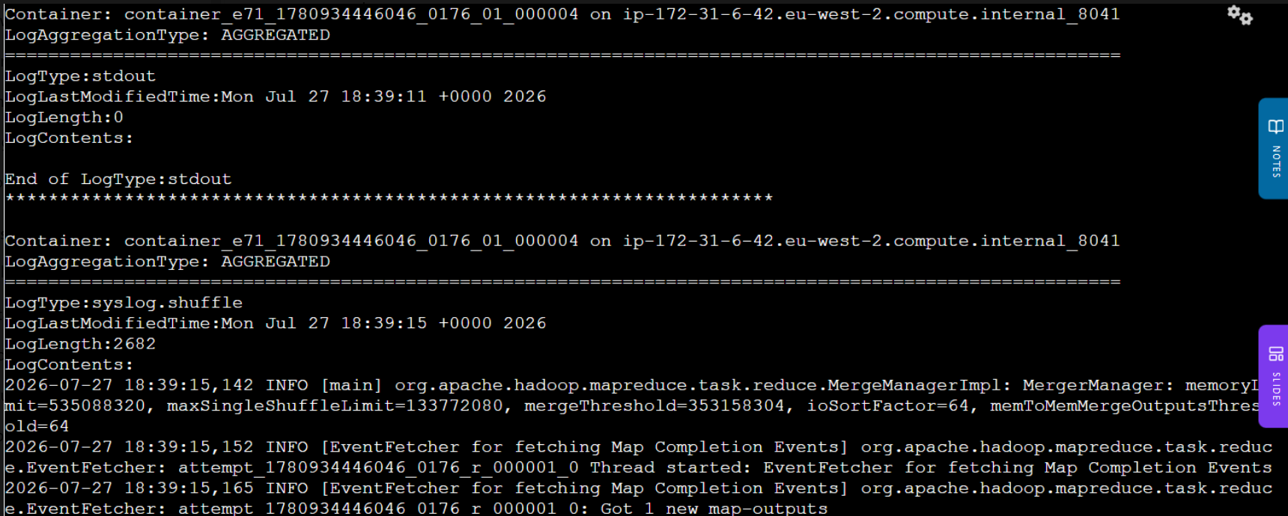

DAY 5
- Create itc_runbook.<yourname>_emp table
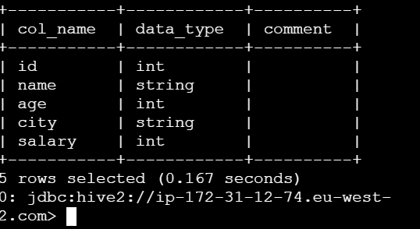
- Load employees data into it
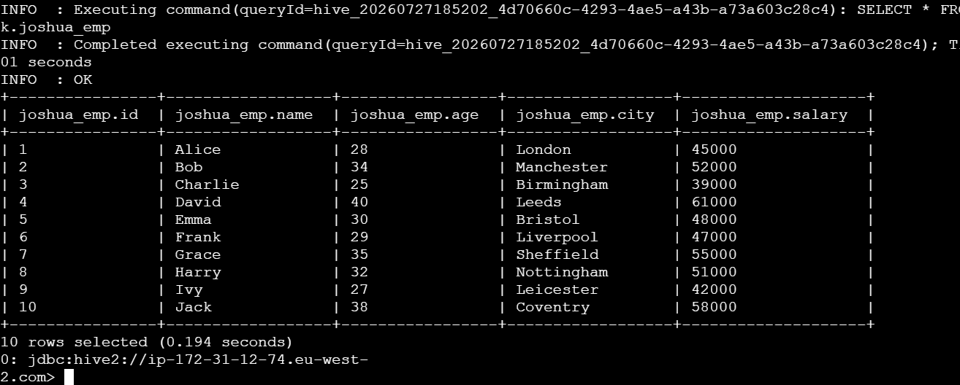
- Query: find all employees aged over 30
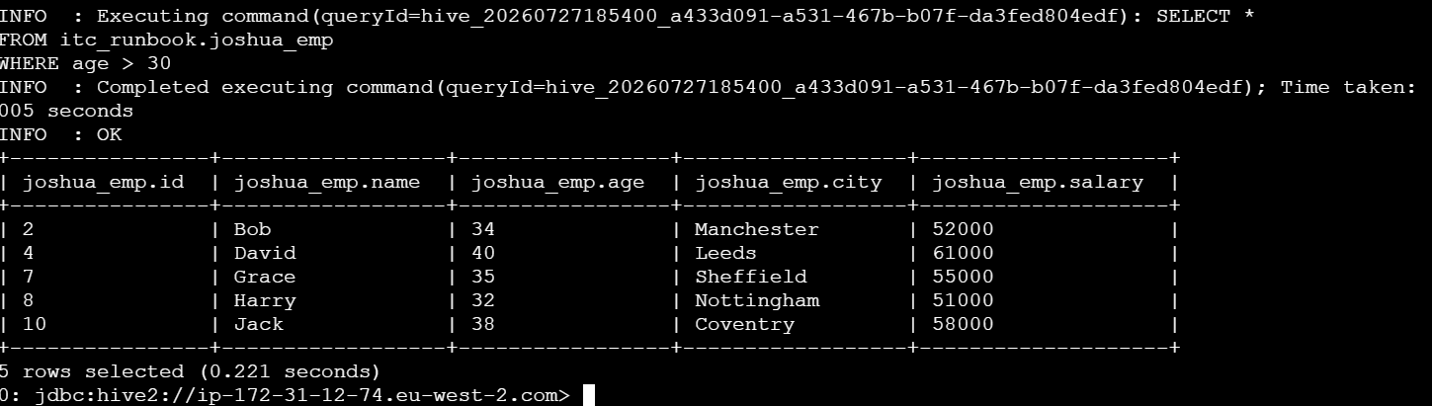
- Query: highest-paid employee in each city
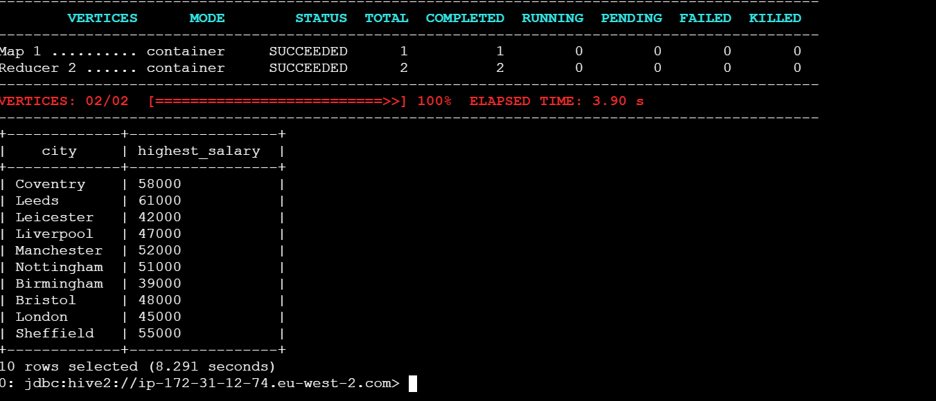
- Create a partitioned version and inspect the HDFS structure under /warehouse
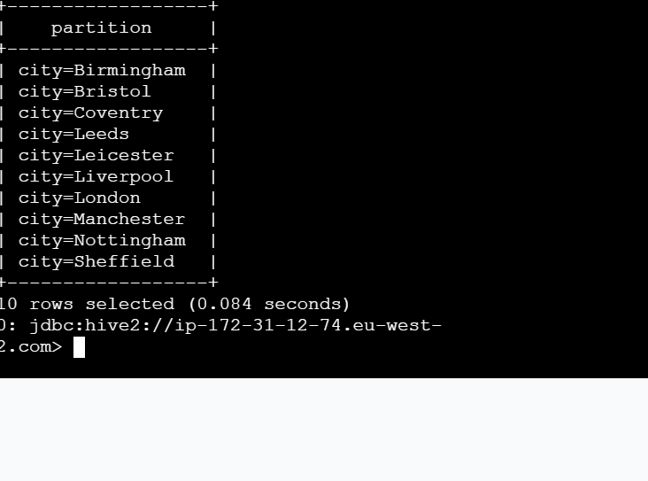
Access was denied when I tried second part

DAY 6
- In Beeline (Hive), create itc_runbook.<yourname>_orders: order_id, product, amount, region
- Insert 5 rows using INSERT INTO ... VALUES (...)
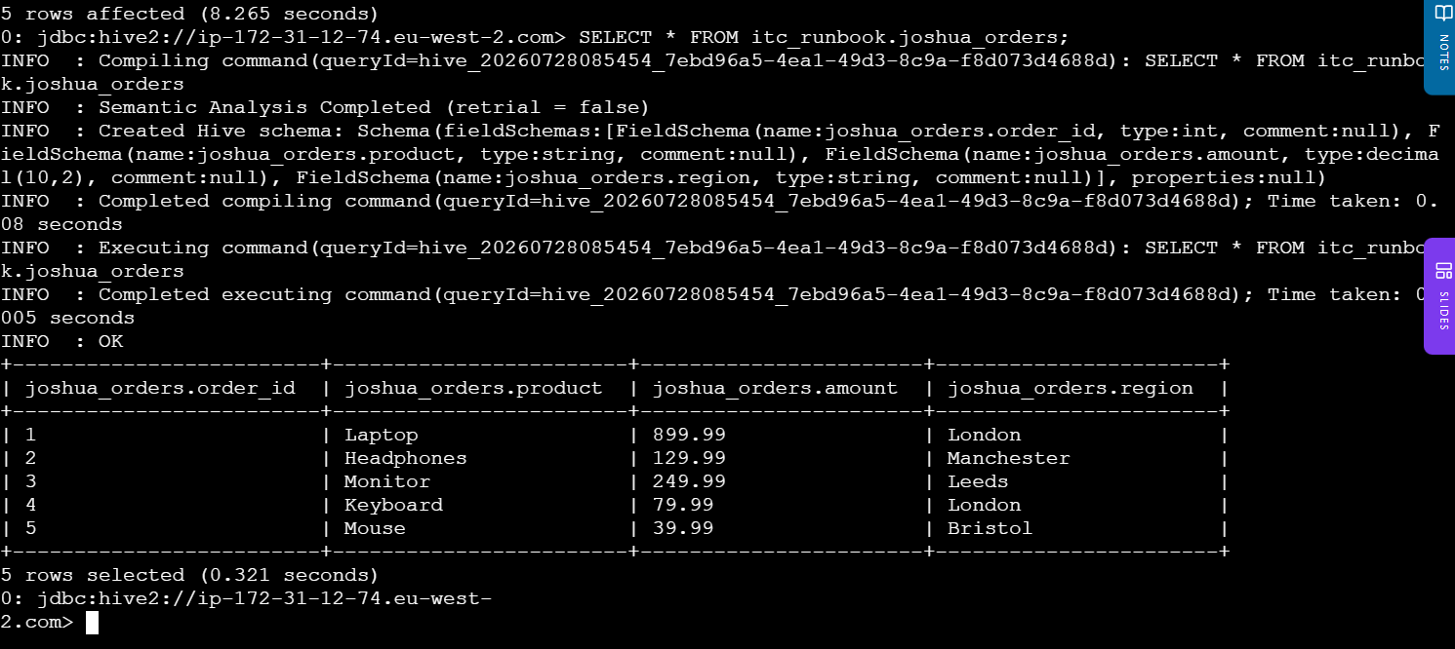
- Switch to Impala shell, run INVALIDATE METADATA
- Query the table — note the speed difference
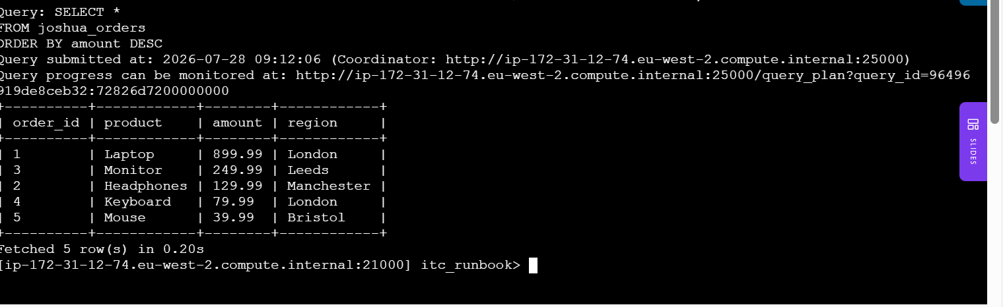
- Run COMPUTE STATS then EXPLAIN SELECT ... to see the query plan
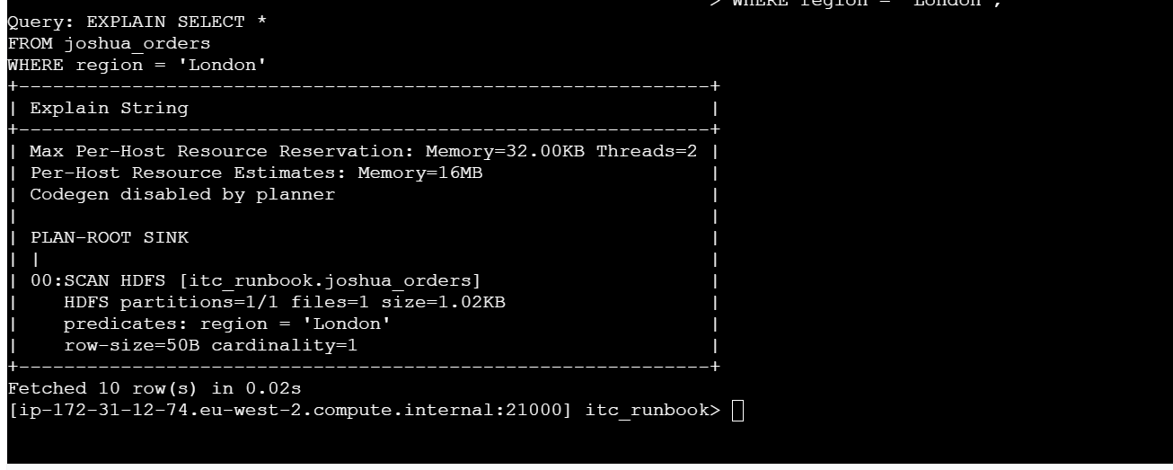

DAY 7
- Open a PySpark shell on the cluster
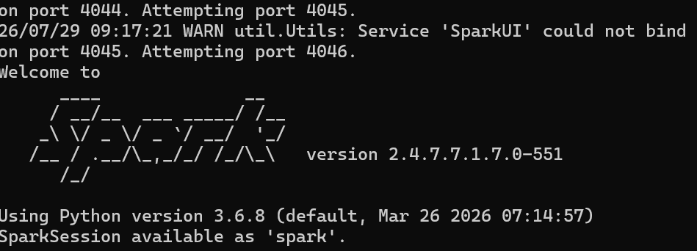
- Read employees.csv from HDFS into a DataFrame
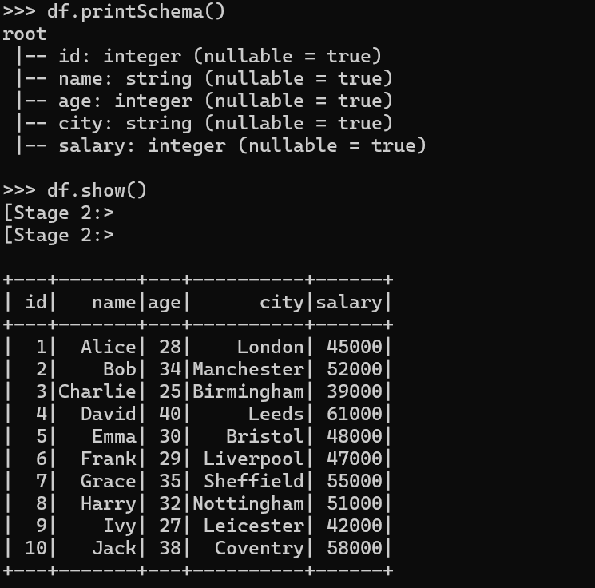
- Add a senior column: True if age >= 35, else False
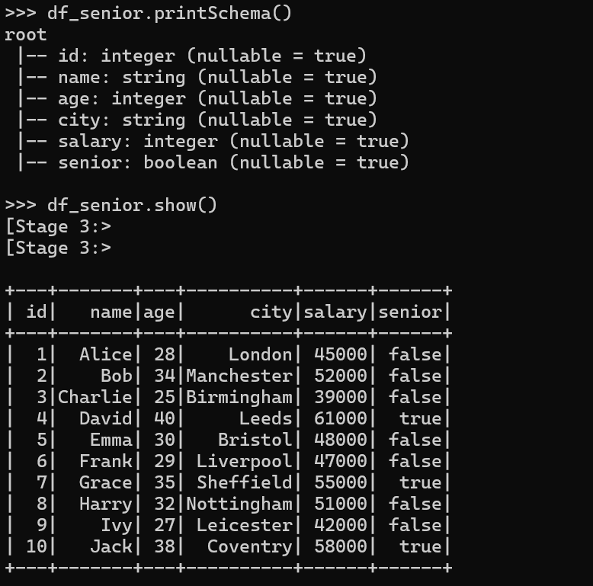
- Calculate average salary for senior vs junior employees
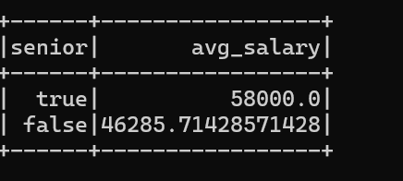
- Write the result as Hive table itc_runbook.<yourname>_analysis
- Verify with beeline: SELECT * FROM itc_runbook.<yourname>_analysis
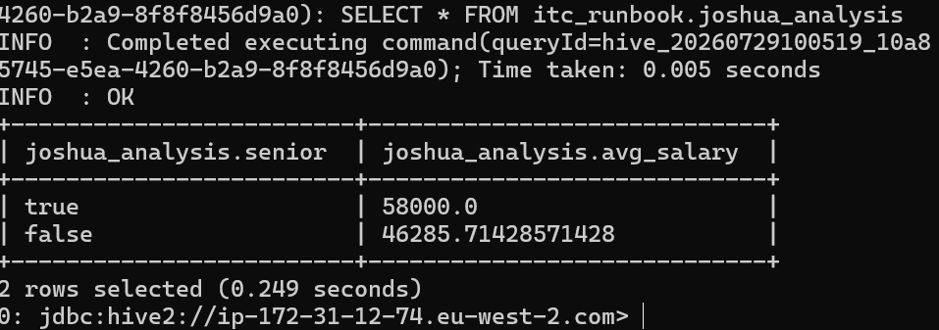

DAY 8
- Create a Kafka topic: <yourname>_test with 3 partitions
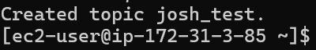
- Write a Python producer that sends 10 employee records as JSON
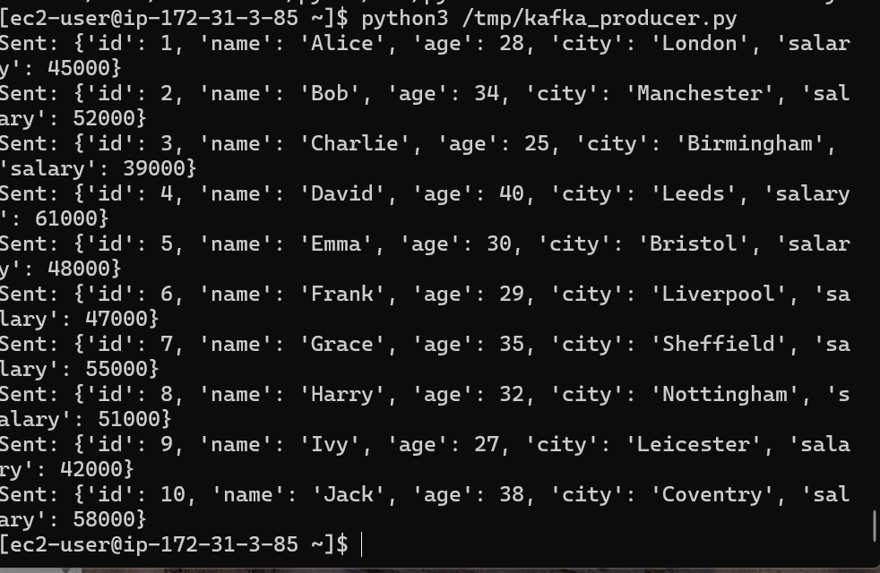
- Write a Python consumer that reads them and prints only salary > 50000
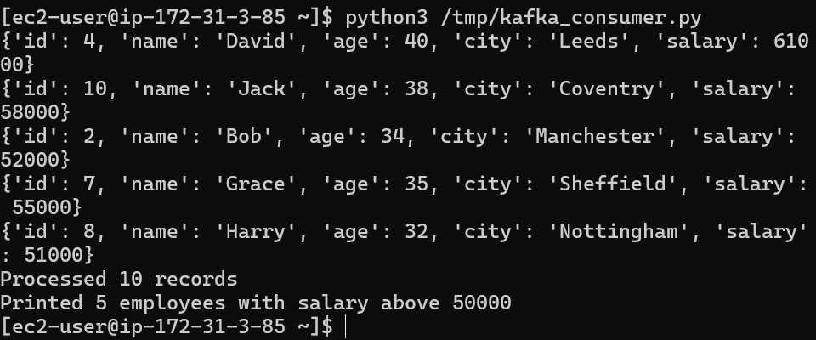
- Check consumer lag with kafka-consumer-groups –describe
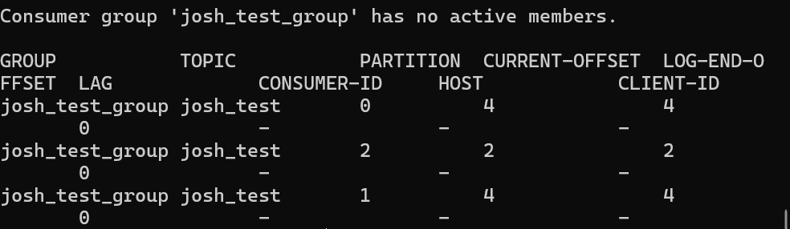
- Delete the topic when done

Day 9 Exercise
- Clone https://github.com/uttamraj9/Test_Spark_Jenkins
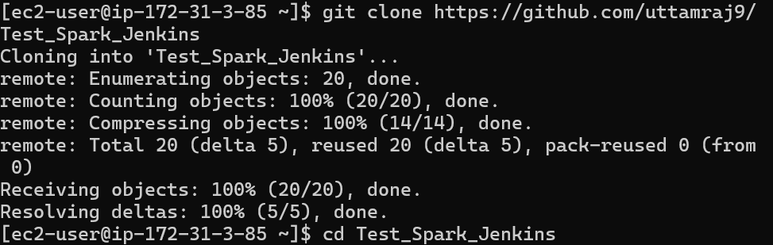
- Create a branch feature/day9-<yourname>

- Add a unit test in tests/ that validates one of the Day 7 transforms
- Push the branch — watch Jenkins pick it up and run the test
- Fix any failures Jenkins reports, push again until green
- Create a Dockerfile that installs pyspark and runs your test script
- Build the Docker image locally: docker build -t itc/<yourname>:1.0 .

